


Public Consulting Group-
Early Intervention Billing
and Claiming Guide

September 30, 2025
April 1, 2026: v.0.1.3

TABLE OF CONTENTS
REVISION HISTORY 2
PROCESS OVERVIEW 3
COMMERCIAL INSURANCE 3
MEDICAID INSURANCE 4
ELIGIBILITY 4
EI BILLING SUPPORT 4
ENROLLING NEW INSURANCE PROVIDERS 7
DEFINITIONS 7

REVISION HISTORY
Version Number | Release Date | Author | Revision Summary
v.0.1.0 | 6/27/2024 | Jill Rigsby
v.0.1.1 | 2/10/2025 | Jill Rigsby | Web-2-Case Update
v.0.1.2 | 9/29/2025 | Jill Rigsby | Annual Update
v.0.1.3 | 4/1/2026 | Jill Rigsby | Six Month Review

PROCESS OVERVIEW
Connecticut (CT) B23 Data System transfers data files to Secure File Transfer Protocol (SFTP) site for PCG to receive. PCG receives data files with the following information from the CT B23Data System. Data extracted from data files and stored in the CT Production Site:

- Child Data
  - Child ID
  - Last Name
  - First Name
  - Date of Birth
  - Gender
  - Address
  - City
  - State
  - Zip Code
o Alternative Billing Last Name
o Alternative Billing First Name
- Visits
- Insurance Authorization
- Practitioner List

All data transferred from the Connecticut B23 Data system is what has been entered into the system by provider agency staff.
Claims are created daily from visits received. Billing records are created and billed daily to a payment source. Claims for children who have been identified as having no insurance are moved directly to escrow daily.

COMMERCIAL INSURANCE
Commercial insurance 837 files are distributed daily to an outside contractor for billing to insurance companies. Commercial insurance 999 report files are retrieved daily from the outside contractor. Commercial insurance files that are rejected on a 999 report are corrected and re-sent by PCG to the outside vendor
Commercial insurance 277 report files are retrieved daily from the outside contractor and processed by PCG. Claims in EI Billing receive 277 status updates and run through the adjudication matrix daily in EI Billing.

Rejected claims that require attention are handled based on who is responsible for resolving them. If the rejection is the responsibility of the provider agency, the provider agency user can address the issue and resend the claim within EI Billing to outside contractors as needed. If the rejection falls under PCG’s responsibility, the PCG support user can resolve the issue and resend the claim within EI Billing to outside contractors on an as-needed basis.

Commercial insurance 835 report files are retrieved daily from the outside contractor and processed by PCG. Within EI Billing, claims receive 835 status updates and are run through the adjudication matrix each day. Claims that are denied are automatically moved to the next payment source, as identified by the CT B23 Data System. For denied claims that require attention, responsibility is divided as follows: if the issue is the provider agency’s responsibility, the provider agency user can resolve and resend the claim within EI Billing to outside contractors as needed. If the issue is PCG’s responsibility, the PCG support user can resolve and resend the claim within EI Billing to outside contractors on an as-needed basis.

MEDICAID INSURANCE
Medicaid insurance 837 claims are distributed daily direct to Medicaid. Medicaid insurance 999 report files are retrieved daily from Medicaid. Medicaid insurance files that are rejected on a 999 report are corrected and re-sent by PCG to Medicaid.
Medicaid insurance 835 report files are retrieved according to the Medicaid billing cycle schedule and processed by PCG. On the date these files become available, claims in EI Billing receive 835 status updates and are run through the adjudication matrix. Claims that are denied are moved to the next payment source, as identified by the CT B23 Data System, on the same date. For denied claims that require attention, responsibility is divided as follows: if the issue is the provider agency’s responsibility, the provider agency user can resolve and resend the claim to Medicaid on an as-needed basis. If the issue is PCG’s responsibility, the PCG support user can resolve and resend the claim to Medicaid as needed.

ELIGIBILITY
Each month, as applicable, PCG creates 270 eligibility request files and distributes them to commercial insurance vendors and directly to Connecticut Medicaid. Commercial 270 files are transmitted to an external contractor, while Medicaid 270 files are submitted directly to the Medicaid agency. PCG receives corresponding 271 eligibility response files from both commercial insurers and Medicaid and stores all responses in the EI Billing system. PCG then generates agency-level reports based on the 271 responses and distributes eligibility status reports to Connecticut Birth to Three (B23) provider agencies and the lead agency.

EI BILLING SUPPORT
PCG hosts a Web-2-Case Customer Service application for CT B23 Providers. All customer service requests will be made through a submission request form within the CT B23 Fiscal Portal. All customer service requests generated through the Web-2-Case system will be handled by the CT B23 EI Billing Team through a triage process.
Below are the screens that a provider will see in the CT B23 Portal. A new link under the Help Menu has been added: “HelpHub Web-2-Case.” This link will open a new window and allow the user to fill in the form and submit a service request.
PCG hosts a Web-2-Case Customer Service application for CT B23 Providers. All customer service requests will be made through a submission request form within the CT B23 Fiscal Portal. All customer service requests generated through the Web-2-Case system will be handled by the CT B23 EI Billing Team through a triage process.
Below are the screens that a provider will see in the CT B23 Portal. A new link under the Help Menu has been added: “HelpHub Web-2-Case.” This link will open a new window and allow the user to fill in the form and submit a service request.
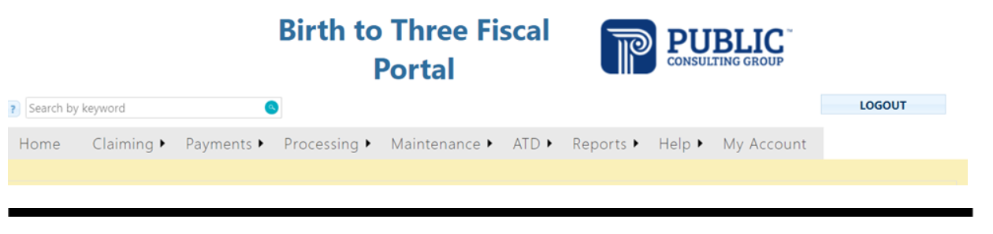
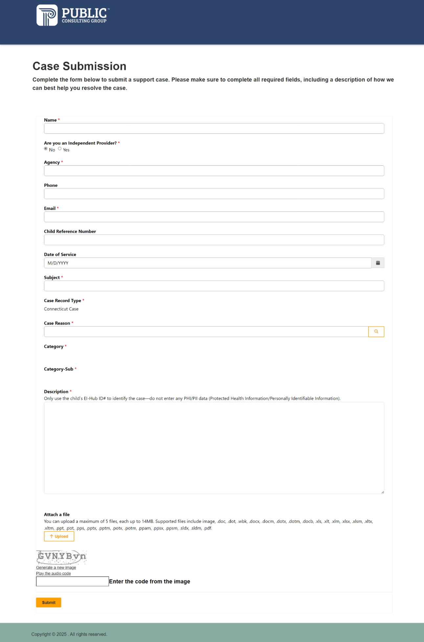
Once submitted the user will see a screen notification that the submission has been successful.

ENROLLING NEW INSURANCE PROVIDERS
CT B23 leadership will notify PCG when a new provider has been added to the B23 system. PCG will contact the new provider and will enroll the provider with the outside vendor for EDI transactions to the most commonly billed insurance companies and CT Medicaid.
In the event of a claim denial due to the provider agency not being enrolled with the applicable insurance carrier, PCG coordinates with the provider agency to facilitate enrollment with the identified insurance provider. B23 will be notified and all claims prior to enrollment will be adjudicated appropriately.

DEFINITIONS
EDI Electronic Data Interchange: system for securely transmitting information between healthcare providers, health care clearinghouses, and payers.
Commercial Insurance 270 Eligibility Request: contains patient data for which detailed eligibility information is requested from insurance companies.
Commercial Insurance 271 Eligibility Response: is the response file from insurance to an inquiry about the health care eligibility and benefits associated with a subscriber or dependent. Commercial Insurance 277: a report acknowledging a receipt of claims from a clearing house. Commercial Insurance 835: a receipt sent by payors to healthcare providers to provide information about healthcare services being paid for, denied, reduced or adjusted.
Commercial Insurance 837: is an electronic document used by healthcare organizations and medical providers to communicate information about a patient’s healthcare claim. Essentially, it serves as an electronic record of a claim.
Commercial Insurance 999 Report File: confirms the initial receipt of the claim file by the contractor, it indicates whether the claim file was accepted or rejected.
Medicaid Insurance 270 Eligibility Request: contains patient data for which detailed eligibility information is requested from insurance companies.
Medicaid Insurance 271 Eligibility Response: is the response file from insurance to an inquiry about the health care eligibility and benefits associated with a subscriber or dependent.
Medicaid Insurance 835: a receipt sent by payors to healthcare providers to provide information about healthcare services being paid for, denied, reduced or adjusted.
Medicaid Insurance 837: is an electronic document used by healthcare organizations and medical providers to communicate information about a patient’s healthcare claim. Essentially, it serves as an electronic record of a claim.
Medicaid Insurance 999 Report File: confirms the initial receipt of the claim file by the contractor, it indicates whether the claim file was accepted or rejected.
Secure File Transfer Protocol (SFTP): a secure method for transferring files over a network. It is designed to protect data from unauthorized access or tampering.

